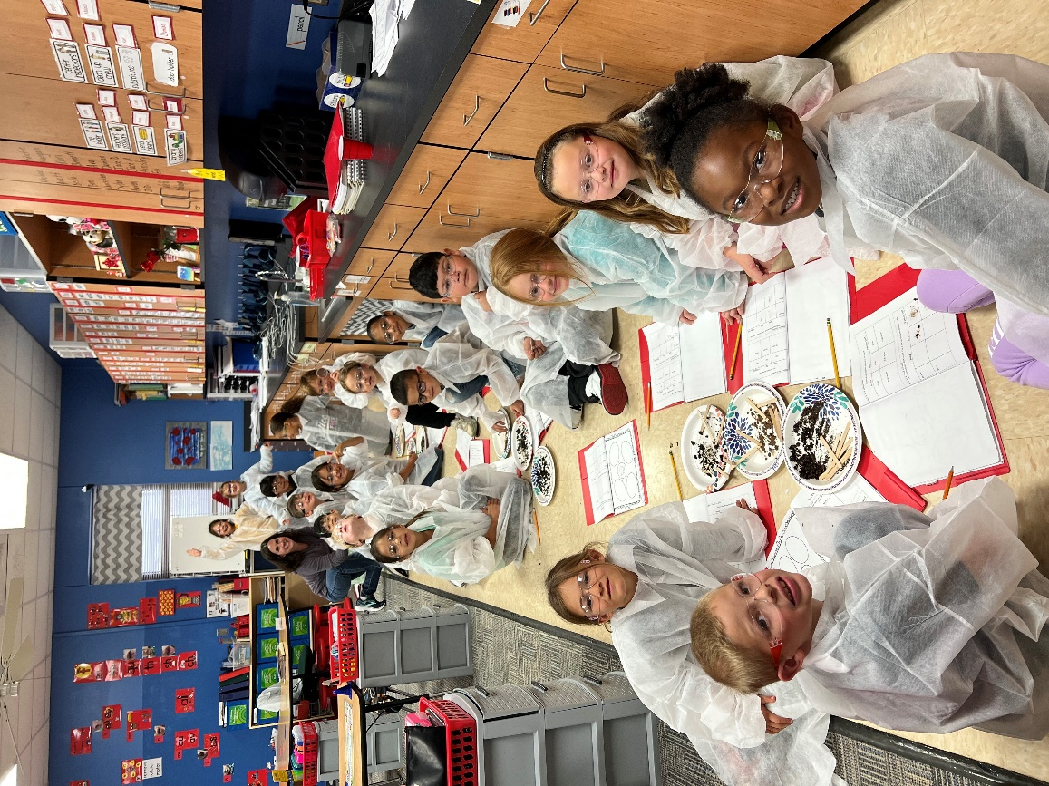

Your Contribution Makes a Difference!

Your Donation Helps KPSF Provide Amazing Learning Opportunities to KISD Students

*If you want to participate for the first time or increase your donation, simply fill out the information requested below.*

⬜ YES, I will support KPSF by donating a monthly contribution of $ _______ and I authorize KISD to deduct this amount from each of my payroll checks beginning the next pay period.

⬜ I elect to change my existing donation amount from $ ________ to $ ________ , effective the next pay period.

⬜ YES, I will support KPSF by making a one-time contribution of $ _____________

*Optional:* This gift is given in honor/memory of _______________________________

**EMPLOYEE NAME: ____________________________________________ CAMPUS: _____________**

**HOME ADDRESS: ____________________________________________________________________**

**SIGNATURE: _______________________________________________________________________**

**DATE: _________________________ EMAIL: ____________________________________________**

**I understand that if I select payroll deduction, my employer, the Kerrville Independent School District, will deduct the authorized amount from my salary each month and remit to the Kerrville Public School Foundation. This is a tax-deductible charitable contribution and I need to keep a record of the amount I donate each year for claiming a deduction on my individual tax return. This authorization shall become effective upon receipt and shall remain in effect until the KISD Payroll Office receives a written notice of cancellation or changes.**



***(KPSF is a 501(c)(3) non-profit organization)***

PAYROLL DONATION PROGRAM